*Table 6*.

X-axis Indoor Positioning Accuracy Test

|  |  |  |  |
| --- | --- | --- | --- |
| Data point | Actual  (In meters) | Prototype  (In meters) | Difference  (In meters) |
| 0 | x | x | x |
| 1 | 0 | 0 | 0 |
| 2 | 0.5 | 0.5 | 0 |
| 3 | 1 | 1.1 | -0.1 |
| 4 | 1.5 | 1.5 | 0 |
| 5 | 2 | 2.1 | -0.1 |
| 6 | 2.5 | 2.9 | -0.4 |
| 7 | 3 | 3 | 0 |
| 8 | 0 | 0 | 0 |
| 9 | 0.5 | 0.3 | 0.2 |
| 10 | 1 | 0.9 | 0.1 |
| 11 | 1.5 | 1.4 | 0.1 |
| 12 | 2 | 2.3 | -0.3 |
| 13 | 2.5 | 2.9 | -0.4 |
| 14 | 3 | 3 | 0 |
| 15 | 0 | 0 | 0 |
| 16 | 0.5 | 0.4 | 0.1 |
| 17 | 1 | 1.3 | -0.3 |
| 18 | 1.5 | 1.9 | -0.4 |
| 19 | 2 | 2.3 | -0.3 |
| 20 | 2.5 | 2.8 | -0.3 |
| 21 | 3 | 3 | 0 |
| 22 | 0 | 0 | 0 |
| 23 | 0.5 | 0.3 | 0.2 |
| 24 | 1 | 0.9 | 0.1 |
| 25 | 1.5 | 1.3 | 0.2 |
| 26 | 2 | 2.2 | -0.2 |
| 27 | 2.5 | 2.9 | -0.4 |
| 28 | 3 | 3 | 0 |
| 29 | 0 | 0 | 0 |
| 30 | 0.5 | 0.3 | 0.2 |
| 31 | 1 | 0.9 | 0.1 |
| 32 | 1.5 | 1.6 | -0.1 |
| 33 | 2 | 2.3 | -0.3 |
| 34 | 2.5 | 2.6 | -0.1 |
| 35 | 3 | 3 | 0 |
| 36 | 0 | 0 | 0 |
| 37 | 0.5 | 0.3 | 0.2 |
| 38 | 1 | 1 | 0 |
| 39 | 1.5 | 1.3 | 0.2 |
| 40 | 2 | 1.6 | 0.4 |
| 41 | 2.5 | 2.6 | -0.1 |
| 42 | 3 | 3 | 0 |

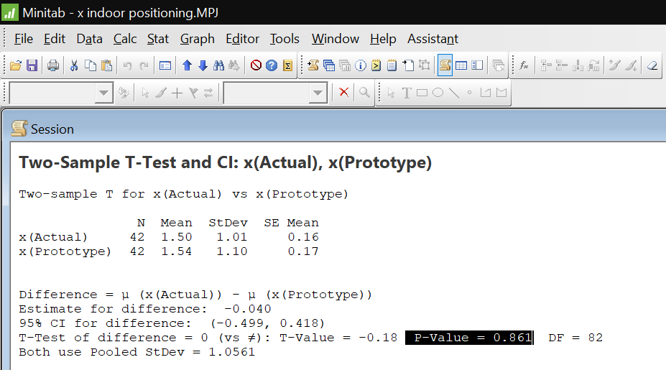

Figure 43.

Two-sample t-test for actual measurement vs. prototype x-axis indoor positioning accuracy test

*Table 7.*

Y-axis Indoor Positioning Accuracy Test

|  |  |  |  |
| --- | --- | --- | --- |
| Data point | Actual (in meters) | Prototype (in meters) | Difference (in meters) |
| 0 | y | y | y |
| 1 | 0 | 0 | 0 |
| 2 | 0 | 0.2 | -0.2 |
| 3 | 0 | 0.4 | -0.4 |
| 4 | 0 | 0.3 | -0.3 |
| 5 | 0 | 0.7 | -0.7 |
| 6 | 0 | 0.3 | -0.3 |
| 7 | 0 | 0 | 0 |
| 8 | 0.5 | 0 | 0.5 |
| 9 | 0.5 | 0.7 | -0.2 |
| 10 | 0.5 | 0.8 | -0.3 |
| 11 | 0.5 | 0.9 | -0.4 |
| 12 | 0.5 | 0.8 | -0.3 |
| 13 | 0.5 | 0.7 | -0.2 |
| 14 | 0.5 | 0 | 0.5 |
| 15 | 1 | 0.6 | 0.4 |
| 16 | 1 | 0.7 | 0.3 |
| 17 | 1 | 0.7 | 0.3 |
| 18 | 1 | 0.7 | 0.3 |
| 19 | 1 | 0.8 | 0.2 |
| 20 | 1 | 0.5 | 0.5 |
| 21 | 1 | 0.7 | 0.3 |
| 22 | 1.5 | 1.3 | 0.2 |
| 23 | 1.5 | 1.4 | 0.1 |
| 24 | 1.5 | 1.4 | 0.1 |
| 25 | 1.5 | 1.3 | 0.2 |
| 26 | 1.5 | 1.3 | 0.2 |
| 27 | 1.5 | 1.3 | 0.2 |
| 28 | 1.5 | 1 | 0.5 |
| 29 | 2 | 1.3 | 0.7 |
| 30 | 2 | 1.7 | 0.3 |
| 31 | 2 | 1.7 | 0.3 |
| 32 | 2 | 1.9 | 0.1 |
| 33 | 2 | 2.1 | -0.1 |
| 34 | 2 | 2 | 0 |
| 35 | 2 | 1.5 | 0.5 |
| 36 | 2.5 | 2.3 | 0.2 |
| 37 | 2.5 | 2.3 | 0.2 |
| 38 | 2.5 | 2.5 | 0 |
| 39 | 2.5 | 2.3 | 0.2 |
| 40 | 2.5 | 2.5 | 0 |
| 41 | 2.5 | 2.4 | 0.1 |
| 42 | 2.5 | 2.2 | 0.3 |

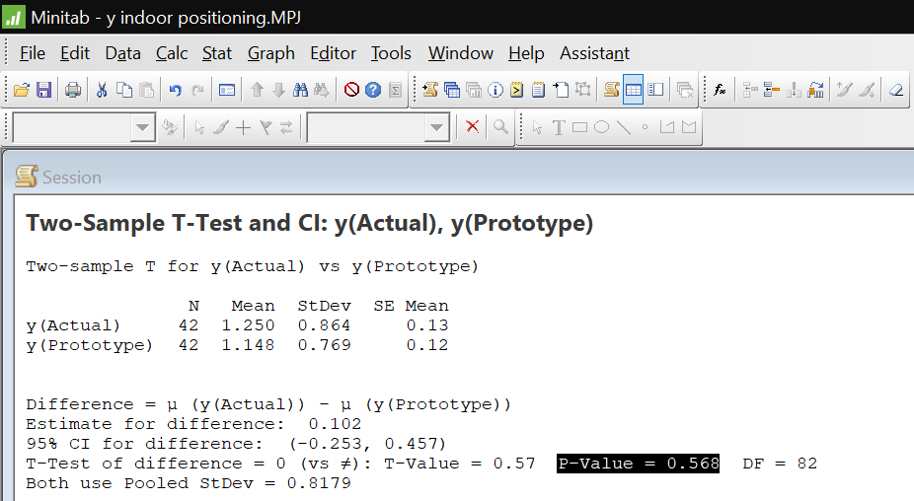

Figure 44.

Two-sample t-test for actual measurement vs. prototype y-axis indoor positioning accuracy test